Kindergarten
Key Concept 3:
My Nation Lesson

Overview: Students will learn that a symbol is something that stands for, or represents, something else. They will learn about the national symbols that are unique to our country. They will complete artwork to depict the symbols. For extension, you may wish to read some non-fiction books with the class about our state symbols that can be found online or in your library. This lesson may take multiple days depending on timing in your class.

Materials Needed:

- Packet (attached)
- Coloring utensils
- Projector or large print outs of symbols you would like to show (you know your class, you know how many symbols they are ready for).

Key Vocabulary:

Symbol
Flag
Allegiance
Liberty
Seal

Objectives:
C.2.K.1 Recognize state and national symbols and patriotic songs
C.2.K.3 Discuss responsibilities of being a good citizen

Instructions:

- Ask students to define the word symbol.
- Clarify that a symbol is something that stands for, or represents, something else.
- A flag is a national symbol that each country has. Like flags, most national symbols are unique to one country. Show them the American Flag and ask students if they can remember the words to the Pledge of Allegiance. Talk about why we pledge our allegiance to the flag and create a class poster with the words or use the print-out provided.
- Ask students to name people, places, and things that they believe represent the United States of America and that are unique to the nation.
- After they have brainstormed various symbols, demonstrate and display all the symbols. Do not discuss much about each symbol, so as to keep the students intrigued about each symbol.
- Have students complete the activity symbols pages below for familiarity and practice.
- Teach the students “My Country Tis of Thee” (lyrics provided).

American Symbols

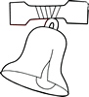

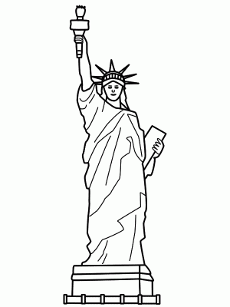

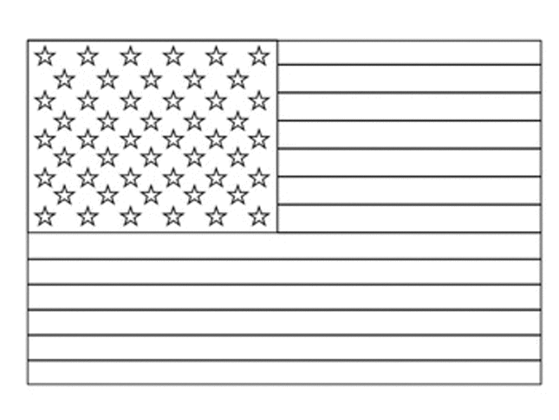
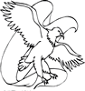

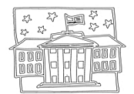

By:

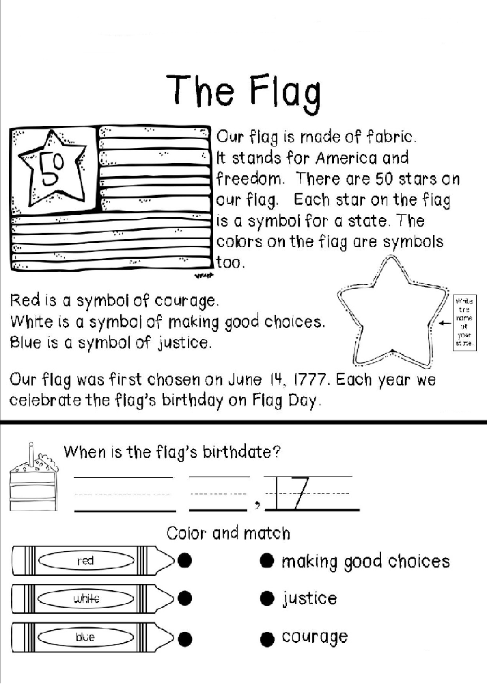
Also known as Old Glory, The Star Spangled Banner, or simply The Stars and Stripes—the U.S. flag has a colorful history. Color the flag below using the key.

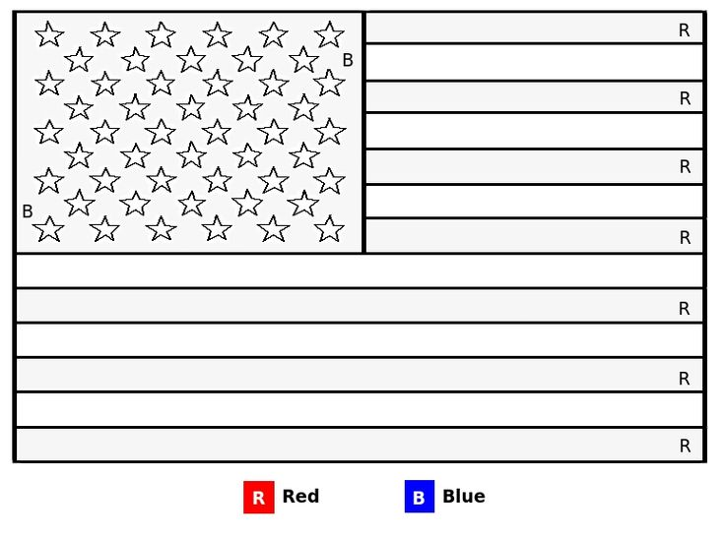

Illustrated by:
The Liberty Bell
The Liberty Bell weighs about 2,000 pounds and is made mostly of copper. It was made in England and is kept and displayed in Pennsylvania. The Liberty Bell is the symbol of Freedom in our country!

Draw your own picture of the Liberty Bell in the box below!

The Bald Eagle

The great bald eagle is the national bird of the United States. It has a brown back, chest and wings; a white head, neck, and tail; yellow feet, legs and beak; and pale yellow eyes. The bald eagle represents strength, courage, and freedom.

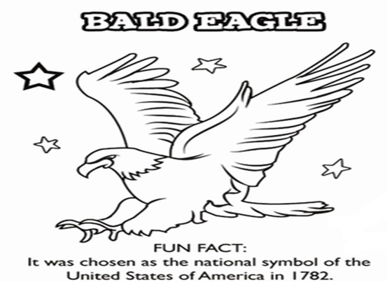

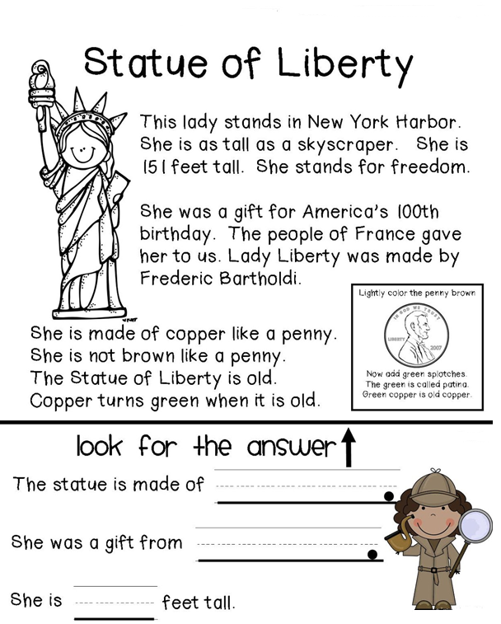

Why is she green?
Before
We used real copper pennies to represent the Statue of Liberty.

During

We soaked the copper pennies in salt and vinegar. Look what happened!

We learned that After

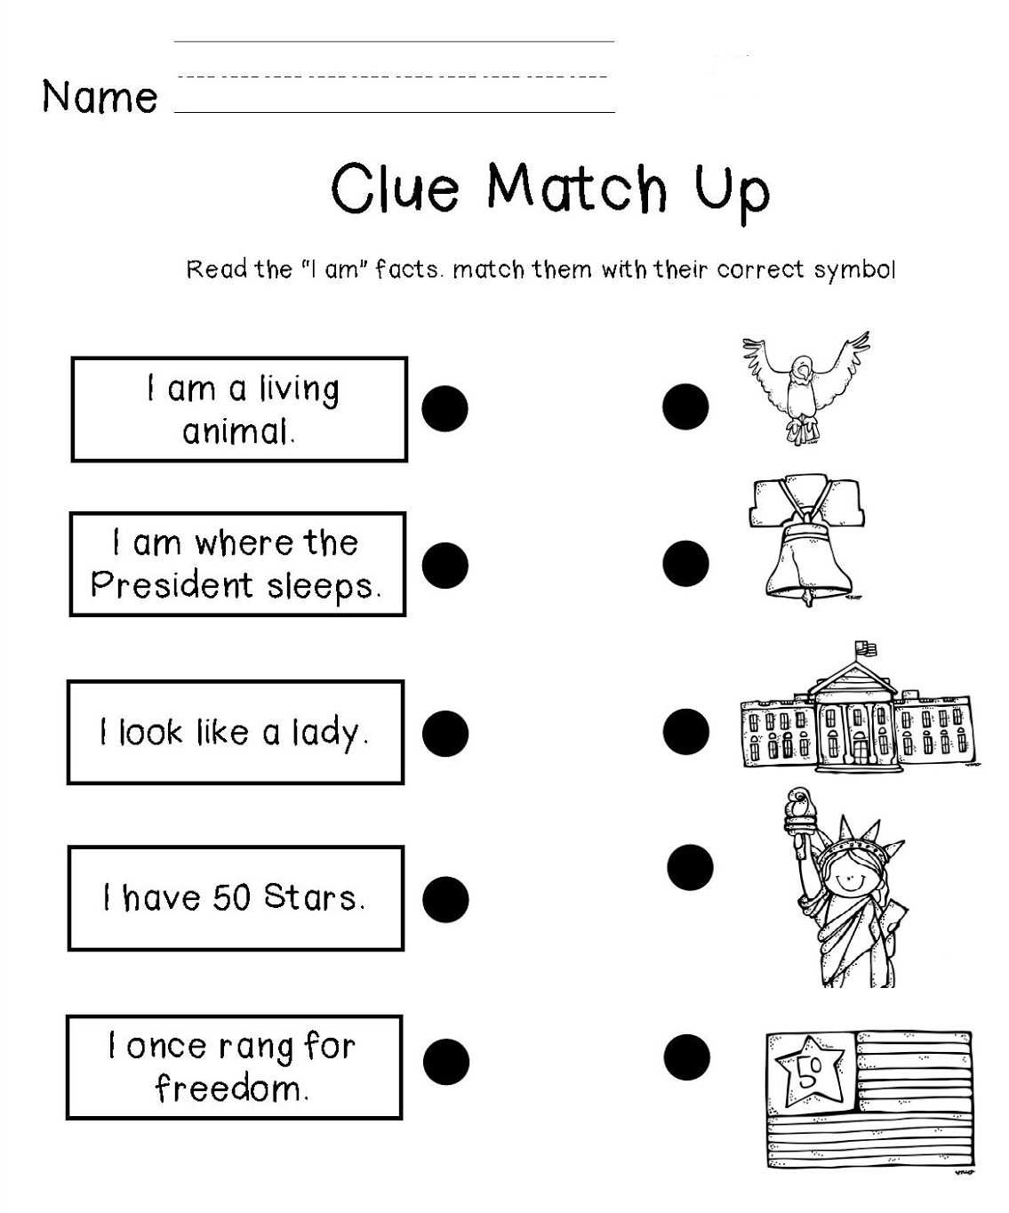

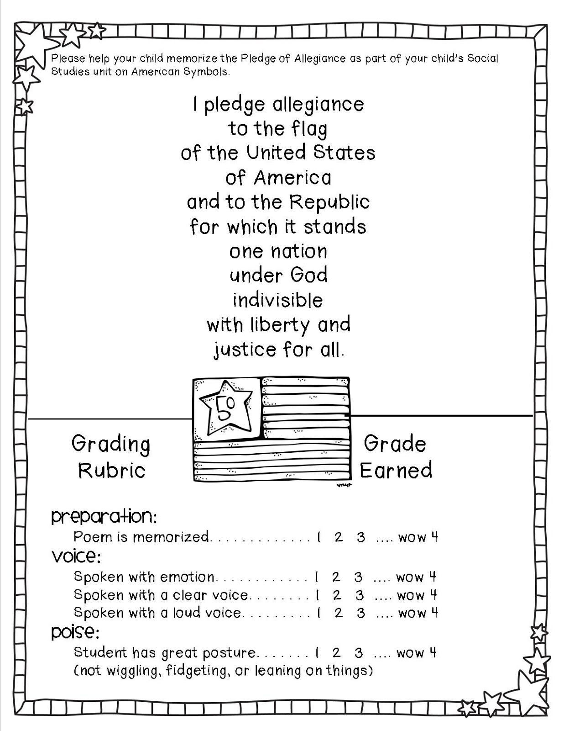
Name:

Parents: We are learning the song “My Country ‘Tis of Thee” in class. If you would like to practice at home, here are the words to help you! Students are only expected to learn the bolded part. However, they can earn something special if they learn the whole song. I have included the music for the piano and guitar for the musically inclined.

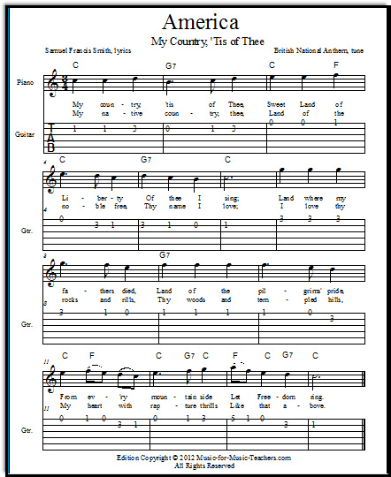
My country tis of thee,
Sweet land of liberty,
Of thee I sing.
Land where my fathers died!
Land of the Pilgrim's pride!
From every mountain side,
Let freedom ring!
My native country, thee,
Land of the noble free,
Thy name I love.
I love thy rocks and rills,
Thy woods and templed hills;
My heart with rapture fills
Like that above.
Let music swell the breeze,
And ring from all the trees
Sweet freedom's song.
Let mortal tongues awake;
Let all that breathe partake;
Let rocks their silence break,
The sound prolong.
Our father's God to, Thee,
Author of liberty,
To Thee we sing.
Long may our land be bright
With freedom's holy light;
Protect us by Thy might,
Great God, our King!

