Kindergarten
Key Concept 7:
Economics and My Community Lesson

Overview: This six-series lesson uses If You Give a Mouse a Cookie as a mentor text to introduce economics terms to kindergarten students. By the end of the unit, students will learn everything from needs and wants to opportunity cost.
For the Teacher: All of the printable materials you need for the lesson are in the attached document. You can use them as you see fit in your classroom. Days 3-6 will require preparation in advance for the class store. You are free to substitute any items in the class store as you deem necessary.
Materials:
Day 1: If You Give a Mouse a Cookie by Laura Numeroff, copies of needs and wants chart (attached)
Day 2: If You Give a Mouse a Cookie by Laura Numeroff, copy of goods and services sort (attached)
Day 3: Trail mix recipe (attached) and ingredients, mixing bowl, mixing spoon
Day 4: items for a class store (erasers, pencils, stickers, etc.), price tags (white labels or index cards will work), play money
Day 5: play money, items for class store
Day 6: Two stuffed animals, two different items for class store, play money
Objectives:
E.4.K.1 Recognize that all people have unlimited wants and limited resources
E.4.K.2 Explain reasons behind a personal decision
E.5.K.1 Identify human, natural, and capital resources
E.5.K.2 Discuss ways producers use human, natural, and capital resources in the production of goods and services
E.6.K.1 Recognize consumers use money as a medium of exchange to satisfy economic wants
E.6.K.2 Discuss reasons people save money
E.6.K.3 Discuss examples of public goods and services
E.7.K.1 Discuss why people trade goods and services

Instructions:
Day One: Needs and Wants
- Tell students that today they will be learning about needs and wants. Create a t-chart on your whiteboard or chart paper titled Wants and Needs. Tell students that a need is something you have to have to live. Allow students to share some needs and write them on your chart. Then, tell students a want is something you would like to have, but isn’t necessary. Record their examples of a want on the chart.
- Tell students that they will read If You Give a Mouse a Cookie to look for things the mouse wants in the book. Read the book aloud, stopping to ask students about the wants of the mouse.
- Hand out the wants and needs chart to each student. (Students can also copy their own if they write independently). Explain they will draw one picture of something they want and another picture of something they need.
- Students will return to their work areas to work on their drawings.
- At the end of the lesson, allow student to share their wants and needs.

Day Two: Goods and Services
- Ask students to review what they learned yesterday about needs and wants.
- Ask students how they can get the things they want (buy at a store). Tell students that something that you can use or buy is called a good.
- Next, ask students about jobs their family members have. Explain that a service is when someone does a job. We pay people to do services. (If you have class jobs, you could also talk about the services they do in the classroom.)
- Read If You Give a Mouse a Cookie again. Stop during the story to ask students about the different goods and services in the book.
- After reading, complete the Goods and Services sort whole-class or in small groups. Sort various goods and services from If You Give a Mouse a Cookie into a t-chart.

Day 3: Resources
- Ask students to review what they learned yesterday about goods and services.
- Ask students what kinds of things are needed to make trail mix. Tell them that resources are things used to make other things.
- Tell them today you will be making trail mix and you need resources. Share the trail mix recipe (attached to end of lesson plan) and point out needed resources.
- Read the recipe again. Add each ingredient to your bowl when it’s mentioned. Ask students to retell the recipe.
- Let students take turns stirring the trail mix and add more ingredients.
- Send students back to their work spot. Allow them to draw pictures and write about the resources used to make trail mix while they enjoy their treat.

Day 4: Money
- Ask students to review what they learned yesterday about resources.
- Ask students how they get the goods they want (money).
- Ask students how people get money (jobs). Allow students to name jobs that they know.
- Hold up the play money and tell the class they will all get paid today to go to the class store.
- Place class store items on a table and have students pretend it is a store. Assign a price tag for each item ($1-$5). Discuss why price tags are important to have in stores.
- Give students different amounts of play money ($1-$5). Discuss how you can only spend as much money as you have.
- Allow students to go to the “store” to purchase items.
- After all purchases are made, allow students to share why the decided to buy their items. If they did not have enough to buy what they wanted, ask them to explain what they needed to do to get enough money (work).

Day 5: Scarcity

- Ask students to review what they learned yesterday about resources.
- Tell a story about a time you tried to make a recipe, but you were out of one of the ingredients, so you could not make the recipe.
- Tell students that scarcity means you don’t have enough resources for people to make or buy something.
- Set up your class store table with goods on it (example: cookies). There should be enough goods for only half the class to buy them. Give the goods a price tag, then give all students enough money to buy it.
- Line students up to purchase their good. When the good runs out, tell the class that half of the class still didn’t get anything.
- Ask the class to explain why half the class wasn’t able to buy anything (scarcity).
- Tell the class that the reason half of the students didn’t get anything is because there weren’t enough resources. This is called a scarcity.
- Make sure to give each student a good at the end of class.
Day 6: Opportunity Cost/Choice
- Tell your students a story about a time you had to choose between doing two things. Ask students if they have ever had to choose between two things. How did they decide which one to pick? How did they feel about leaving the other option out?
- Tell the class that when we make a choice, we have to give something else up. Opportunity cost is what we give up to make our choice.
- Show the class two different stuffed animals. Tell the class that you have $5 (play money). You would like buy both, but they both cost $5. Explain that you need to make a choice between the two stuffed animals. Choose one of the stuffed animals, and explain that the item you gave up is your opportunity cost.
- Place a few items on your “class store” table. Ask a few students to come up and select an item. Then, have the class explain what the opportunity cost is.
- Next, display two different items on your “class store” table (candy or cookie, pencil or eraser, etc.). Give each student enough to buy only one item. Allow students to make their purchases. After the class makes their purchase, ask them what their opportunity cost was.
- Allow students to go back to their work spaces. Give them the opportunity cost handout. Allow them to demonstrate their knowledge by writing and illustrating their choice and opportunity cost.
Thank you to Krista Calvin from Clear Creek Elementary School for providing great ideas for kindergarten economics. http://clearcreek.cksd.wednet.edu/Economics/kinder.htm
Also, be sure to check out Economics Arkansas at http://www.economicsarkansas.org/ for great economics lesson and ideas for your classroom!

Kiddos Favorite Trail Mix
Serves 15-20
1 cup Cheerios toasted oat cereal (honey nut, plain, and apple work equally well)
1 cup Goldfish/cheese crackers
1 cup dried cranberries (or other favorite dried fruit)
1 cup cashew or other favorite nuts (in case of allergies, substitute raisins)
1 cup mini M&M’s or chocolate candies
1 cup peanut butter or butterscotch chips
1 cup pretzel twists or sticks

Economics Word Wall
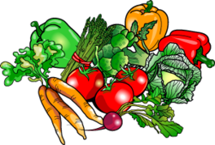
Need
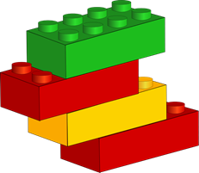
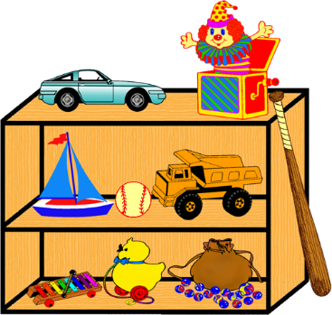
Want
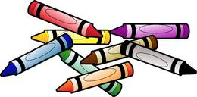
Good
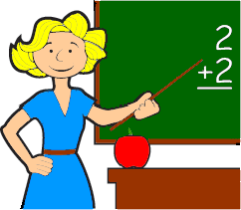
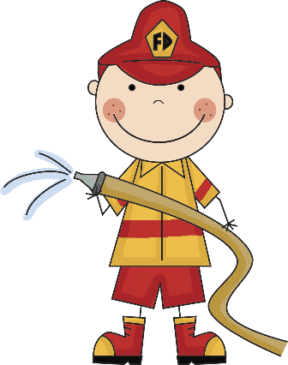
Service
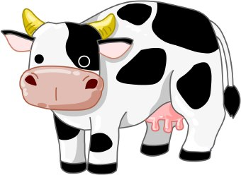
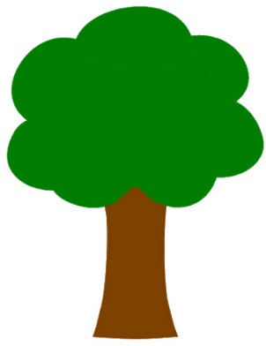
Resource
Money
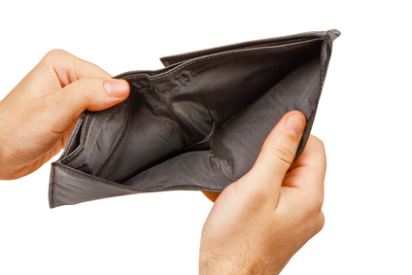
Scarcity
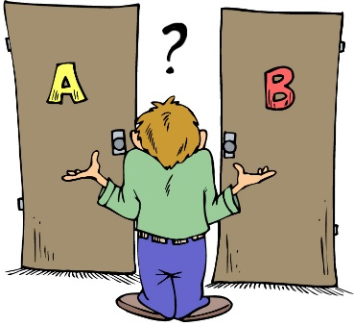
Opportunity Cost
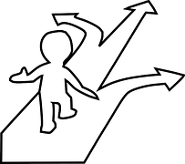
Choice

Goods and Services Sort
Drawing picture | 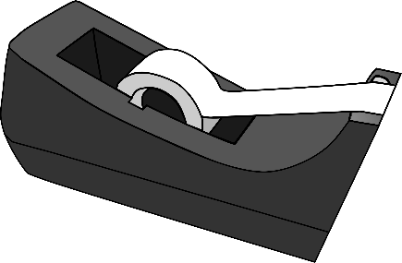  Scotch tape
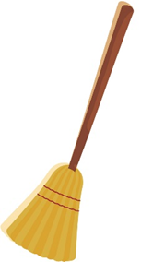  Sweeping | 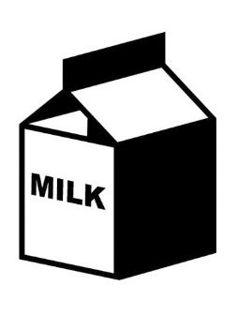  Milk
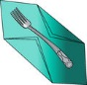  Napkin | Trimming hair 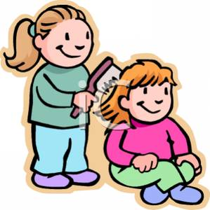
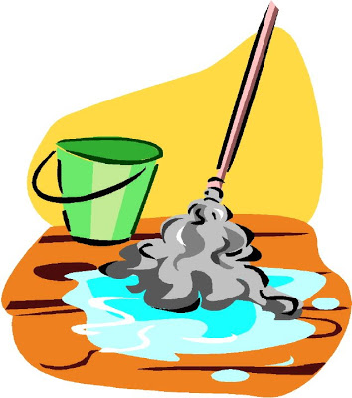  Washing floors | Cookie
Books | Fluffing pillow

Good | Service
Needs and Wants
Name _______________ Date ___________
Things I need… | Things I want…
Opportunity Cost
Name _______________ Date ___________
My choice was…  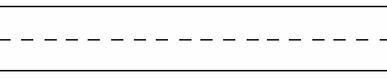 | My opportunity cost was…

