Second Grade
Key Concept 5:
People Who Changed History Lesson

Overview:

This is an interactive technology-integrated lesson plan on introducing third graders to the Constitution. The lesson is best done with a set of computers for the classroom or at least every pair but would also be easy to do with a teacher computer and projector screen. It includes an online matching game as well as a student worksheet.

Materials Needed:

- Teacher computer and Projector
- Class set of computers (if possible, not necessary)
- Class set of scissors
- Class set of glue sticks
- Student worksheet

Key Vocabulary:
Constitution
George Washington
Philadelphia
Liberty Hall
John Adams
Benjamin Franklin
Laws
Supreme Court
Congress
Executive

Objectives:
C.1.2.1 Identify founding documents of the United States
C.1.2.2 Describe roles and responsibilities of people in authority in local communities
C.2.2.1 Explain the significance of state and national symbols, patriotic songs, and mottos
H.12.2.5 Explain historical symbols and landmarks and the people and events associated with them

Instructions:
- Visit this website and click on the 2nd-3rd grade tab: http://www.k12.com/constitution-day.html
- Walk through the 6 slides with your students, popcorn reading out loud around the room.
- Play the Constitution matching game as a class or in pairs if you have a class set of computers.
- Have students show what they learned with the worksheet attached (you need to print this piece, it is not a digital worksheet!)

U.S. Branches of Government

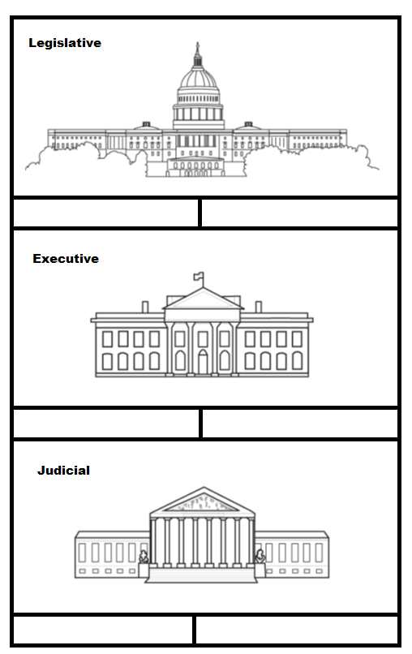
The U.S. Constitution sets up three branches of government. Each branch is responsible for certain tasks. The legislative branch is the Congress. The main job of Congress is to make laws. The president is the head of the executive branch, which carries out laws that Congress makes. The Supreme Court is the highest court of the judicial branch. The courts explain what the laws mean. Directions: Cut apart the words or phrases on the side. Match the words or phrases to the correct branch of government, and then paste them in the boxes below each building.
defines law meanings
carries out laws
makes laws
Supreme Court
President
Congress

Arkansas Branches of Government

The Arkansas Constitution sets up the State Government into three branches. Each branch is responsible for certain tasks, very similar to the U.S. government. The legislative branch is made up of the House of Representatives and the Senate, just like Congress is, but it is simply referred to as the Legislature. The main job of the Legislature is to make laws. The Governor is the head of the executive branch, which carries out laws that the legislature makes. The Supreme Court is the highest court of the judicial branch in Arkansas. Decisions made in the Arkansas Supreme Court can only be overturned by the United States Supreme Court. The courts explain what the laws mean. Directions: Cut apart the words or phrases on the side. Match the words or phrases to the correct branch of government, and then paste them in the boxes below each building.

Governor
Legislature

makes laws
Supreme Court

carries out laws
defines law meanings

