Fourth Grade
Key Concept: 6
Natural Regions of Arkansas

Overview: This lesson offers a brief overview and great introduction to the six natural regions of Arkansas. We have also provided additional resources and extension materials from the Arkansas Educational Television Network as well as the Natural Heritage Commission.

For the Teacher:
The Arkansas Educational Television Network has videos about each of the six natural regions, as well as extension activities. http://www.aetn.org/programs/sixregionjourney
The Natural Heritage Commission has additional lesson plans about the ecosystems within each region of Arkansas. http://www.naturalheritage.com/Education/ecoregions-natural-divisions-of-arkansas

Materials:
Natural Regions of Arkansas PowerPoint (provided), Regions of Arkansas foldable (provided), map of Arkansas regions (provided), scissors, coloring materials, glue, projector

Objectives:
G.8.4.2 Use thematic maps and other geographic representations to compare physical and human characteristics of a region to those of another region in the United States and the interactions that shape them
G.8.4.3 Construct maps and other geographic representations of Arkansas and the United Sates including physical and human characteristics, title, legend, and compass rose
G.10.4.1 Compare natural resources in various geographic regions to influence human settlement patterns
H.12.4.3 Compare specific regions of the United States in the past with those regions today noting changes over time

Instructions:
- Tell your students that you will be learning the six regions of Arkansas. Tell them that regions are divided by the landforms and resources available in that region.
- Give each copy of the Regions of Arkansas foldable.
- Instruct students to arrange the foldable by putting the side of the paper with the names of regions face down. Then, fold up the left and right side of the foldable and seal it along the black lines. The paper will now look like two doors. Use scissors to cut tabs along each line that separates the region names, stopping at the crease of the paper. The tabs should open up to reveal the “Things to See” and “Resources” headings. (If you are using an interactive notebook, you can glue the back of the foldable into your notebook.)
- Display the Natural Regions of Arkansas PowerPoint. Tell students that they will be learning about things they will see in each region, and resources that region provides. They will record notes in their foldable.
- Go through each region of Arkansas on the slideshow. You may also want to supplement the slideshow with videos from AETN’s “Arkansas: A Six Region Journey” series.
- As you are going through the slides, stop to allow your students time to record notes from the slideshow into their foldable.
- After going through the slideshow, review with the students what they learned about each region.

Assessment
- Have your students create their own map of the Arkansas regions.
- Give each student a copy of a blank regional map.
- Instruct students that they will be designing their own maps of the Arkansas regions. Using their notes from their foldable, they will label each region of the state. Then, they will design pictures that relate to each region and put them on the map. For example, they may draw farms in the Delta region or oil rigs in the Coastal Plain region.
- Use the rubric (attached) to grade their regional Arkansas map.

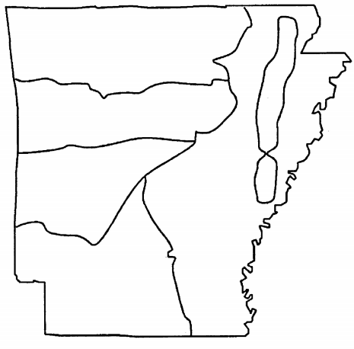
Regions of Arkansas

Regions of Arkansas Map Rubric
 | 1 | 2 | 3
Knowledge of Region | 1 characteristic of the region is featured/the characteristics are not related to the region. | 2 characteristics of the region are featured. Most or all related to the region. | 3 or more characteristics of the region are featured. All are related to the region.
Organization | Little organization was put into the labels and illustrations. | The labels and illustrations are mostly neat and detailed. | The labels and illustrations are very neat and detailed.
Creativity | The map contains little color and several white spaces. | The map is mostly colorful with a few white spaces. | The map contains colorful illustrations with little white spaces.

